Disaster Preparedness and Response Education System for Schools and Colleges

Ms.Pushpalatha  Assistant Professor  Presidency University, Yelahanka  Bangalore, Karnataka, India | Shreya A J  Department of CSE-IoT  Presidency University, Yelahanka  Bangalore, Karnataka, India | Manisha S M  Department of CSE-IoT  Presidency University, Yelahanka  Bangalore, Karnataka, India

Nithya H D
Department of CSE-IoT
Presidency University, Yelahanka
Bangalore, Karnataka, India

Abstract— Spend any time looking at India's disaster record and one pattern becomes impossible to ignore — these events are not rare, and they are not getting rarer. Floods, earthquakes, cyclones, landslides, fires — millions of people encounter these hazards every year, often with very little preparation. Schools and colleges are particularly exposed. They gather large numbers of people under one roof daily, yet most have no genuinely structured readiness mechanism in place. This is not for lack of guidance. The NDMA has laid out what institutions should be doing. UNDRR frameworks have called explicitly for disaster education to be embedded in formal schooling. The gap is not in the policy — it is in the implementation. What exists in most institutions today amounts to occasional awareness talks and drills that nobody quite remembers by the time the next one rolls around, with nothing in between to turn that exposure into reliable, measurable preparedness.
A college in interior Karnataka faces a completely different risk landscape. The system accounts for this by tailoring disaster content to the actual hazard profile of each region rather than pushing the same material everywhere. On the development side, the V-Model SDLC meant requirements were not just written and forgotten — every functional and non-functional requirement was actively verified at each stage before the team moved ahead.

- INTRODUCTION
The ground across this country has a history of moving — and the communities built on it have paid the price often enough to know it.
Urban fires present a quieter but equally serious threat — in Indian cities where buildings press up against one another with barely any gap, fire has very little stopping it once it starts.
On paper, the framework is solid. The NDMA has published school safety guidelines that are detailed and well-considered. UNDRR frameworks have long argued for embedding disaster risk reduction directly into formal education. The intent is clear. The implementation is another matter entirely. The brain is ruthlessly efficient — it holds onto what gets used and quietly discards what does not. Emergency procedures that are practiced once and never revisited fall into that second category faster than most educators would be comfortable admitting. A month after a drill, recall starts slipping. Six months later, the details are largely gone. A student in that situation is not prepared for an emergency — they are simply someone who was briefly walked through one, once, under no pressure whatsoever. The issue was never a lack of guidelines. It is the absence of any mechanism that turns those guidelines into something measurable and ongoing.
What makes this gap especially worth addressing is the disconnect between knowing and doing. A student might know that moving away from windows during an earthquake is the right move, but in a real emergency — with noise, confusion, and fear — that knowledge rarely converts automatically into the right behavior. Physical drills are resource-intensive and disruptive enough that they happen rarely. And when they do take place, the content is rarely tailored to the specific disaster profile of that region.
This paper presents the Disaster Preparedness and Response Education System for Schools and Colleges, a web-based platform that integrates disaster learning modules, virtual simulation drills, administrative dashboards, and preparedness assessments into a single unified system. The objective is to make disaster education continuous, interactive, region-specific, and measurable — rather than an annual checkbox that gets forgotten within a week.

LITERATURE REVIEW
- Importance of Disaster Preparedness
UNDRR-aligned research has documented this distinction carefully — institutions that build active preparedness cultures, where students practice emergency procedures regularly, see measurably better outcomes when real events occur. Panic is reduced. People act together instead of scattering. Implementation has remained patchy across institutions as a result. The program that once ran on a clear schedule now runs on whoever remembers to organize it. That pattern plays out across institutions more often than anyone would like to admit.

- Emergence of E-Learning Platforms for Disaster Education
A student who had a test to prepare for could come back to the safety module later. Someone who did not quite follow the section on evacuation procedures could replay it without feeling embarrassed about asking a teacher to repeat themselves. The interactivity helped too — clicking through a quiz is a fundamentally different experience from staring at a printed page. Were these platforms polished or particularly advanced? Not really. But they made the learning experience noticeably more human. Accessibility improved considerably. But most of these platforms stopped at content delivery — they offered no realistic simulations or scenario-based decision-making exercises.

- Limitations of Traditional Awareness-Based Education
Responding to a real disaster requires fast judgment under pressure — exactly the kind of capability that passive, lecture-based instruction does not develop. The gap between what students know and how they actually behave in a crisis is well-documented and persistent.

III. EXISTING METHODS
Most institutions follow NDMA guidelines that center on evacuation planning and periodic awareness sessions. These form a useful baseline, but they are episodic by nature — there is little mechanism for ongoing engagement, performance tracking, or continuous improvement.

A. Manual Evacuation Drills
Evacuation drills are the most widely adopted preparedness tool in educational institutions. Students and staff practice clearing classrooms through predefined safety routes. The method familiarizes people with exit locations and assembly points, which genuinely matters. Ask any student what happened during last year's evacuation drill and watch how quickly the details blur. The route, the assembly point, who gave instructions — it all starts fuzzing out within weeks. That is not a criticism of students. It is just how memory works when something is experienced once and never revisited. Running drills once or twice a year creates a brief window of familiarity that closes long before the next drill opens it again. As a strategy for building reliable emergency response, it barely qualifies as one.

B. Students Awareness Programs

That foundation matters. The trouble is that a lecture can only take someone so far. The knowledge is there. The pressure, the noise, the confusion — none of that is. And those are precisely the conditions under which that knowledge needs to work.

C. Cloud-Based Disaster Management Information Systems

Cloud-based systems have been developed mainly to support administrative coordination during emergencies — incident reporting, data aggregation, and response monitoring at the institutional or government level. There is nothing wrong with these platforms on their own terms. They were built for a particular job and they do it. The issue is that their particular job is not educating students — it is helping authorities track and coordinate disaster response. Those are two very different things, and the feature gap reflects it. No simulation. No preparedness score. No interactive scenario that challenges a student to think under pressure. For school-level disaster education, these tools are the right answer to the wrong question.

Gamification as a Tool to Increase Engagement

Some platforms have explored gamification —reward systems, interactive challenges, and scenario-based games — as a way to raise student motivation in safety training. The approach has generally worked in terms of engagement; students participate more actively when training feels like an activity rather than a lecture. The gap lies at the administrative layer.

Limitations of Current Approaches
Traditional approaches are too infrequent and passive to build lasting behavioral readiness. VR simulations offer strong results but require expensive hardware that most schools cannot afford. Early warning systems focus on alert dissemination rather than training. There is a certain irony in the fact that platforms built to support disaster preparedness often leave administrators flying blind. Real-time monitoring is missing. Content stays generic regardless of what hazards a particular region actually faces.

IV. PROPOSED METHODOLOGY
Building three separate tools — one for learning, one for simulation, one for monitoring — and hoping institutions would use all three consistently was never a realistic option. The methodology was built around integration from the start. One platform, one login, one place where everything happens and everything gets recorded.

Interactive Disaster Learning Modules.
Generic disaster content has a well-known problem — it covers everything and prepares nobody in particular. The learning modules were designed around the opposite logic. Users choose a disaster category relevant to their region, and what they get is content built around that specific hazard — its characteristics, the precautions that genuinely reduce harm, and the response procedures worth knowing cold. Anyone who has sat through a mandatory safety briefing knows what happens when information is presented as an unbroken block of text — eyes glaze over, attention drifts, and very little actually lands. The platform was designed with that reality in mind.

Virtual Simulation and Drill System
Reading about which exit to use during a fire is easy. Choosing the right one when smoke is spreading and the obvious route is blocked is not. The simulation component was built around that gap. Users are placed in scenarios that do not announce themselves politely — a fire breaks out, an earthquake strikes, and suddenly a decision needs to be made right now. The system tracks those decisions, scores them, and delivers feedback before the next scenario begins. The environment is digital and the stakes are low, but the habit being built is real. That is the entire point of running the same situations repeatedly — not to test what users know, but to train how they respond.

C Administrative Dashboard and Preparedness Monitoring
Running a preparedness program without monitoring data is essentially running it on faith. The administrative dashboard was built to fix that. Faculty and administrators get a single consolidated view of everything that matters — which students completed which modules, how they scored on quizzes and simulations, whether performance is trending up or flatlining, and what the overall preparedness picture looks like across the institution. Individual reports, group reports — both are available without any manual data collection. For the first time, the people responsible for institutional safety can see what is actually happening rather than assuming everything is fine because nobody has complained. This turns disaster education into something measurable and improvable.

D. Growth, Accessing capacity, and Real-Time Updates
One of the quieter strengths of the platform is that growth does not break it. Bringing in a new school, adding users by the hundred, or introducing an entirely new disaster category does not mean going back to the drawing board — the architecture was built to absorb that kind of expansion without drama. The same goes for device access. A student checking modules on a smartphone gets the same experience as one sitting at a desktop, which matters in a country where a phone is often the primary and only screen available. Content updates work the same way — an administrator can push revised safety guidelines or updated simulation scenarios at any point without taking anything offline or interrupting anyone mid-session.

E. Workflow Overview
The integrated workflow proceeds through four stages:
- User registration and login
- Selection of disaster module and completion of learning content
- Participation in virtual simulation and assessment
- Performance monitoring and report generation by administrators
Students begin by logging in and selecting a disaster category. After working through the structured content, they attempt a simulation or assessment. Results are stored automatically and surfaced in the administrative dashboard, creating a continuous record of engagement and performance that institutions can act on over time.

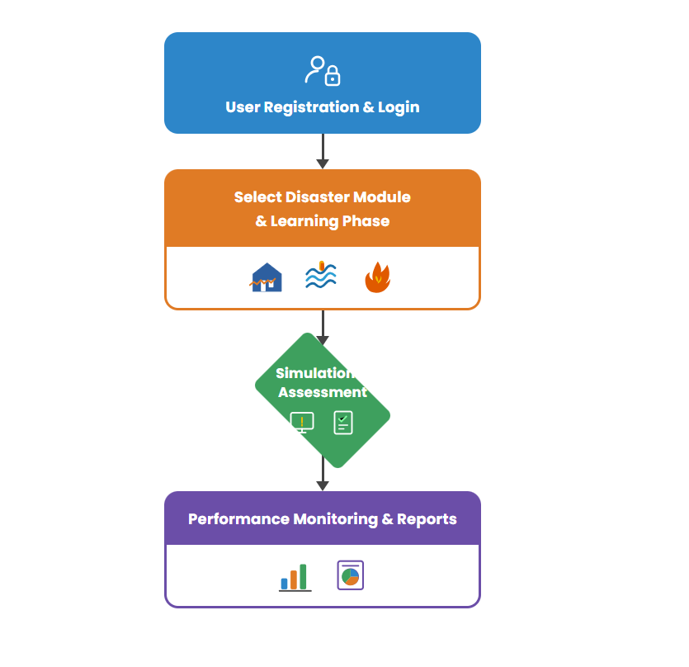

V. OBJECTIVES
There is a version of disaster preparedness that lives entirely on paper — policies drafted, guidelines approved, boxes ticked. And there is a version that actually exists in the behavior of students and staff when something goes wrong. The gap between those two versions is exactly what the system was built to address. The objectives were not written to satisfy a checklist. The specific objectives that follow each address one part of making that happen. Some of them are:

To Upskill Disaster Awareness and Knowledge
None of the more sophisticated features — the simulations, the scoring, the dashboards — matter if students do not have a working understanding of what they are preparing for. That is the starting point the first objective addresses. What does a flood actually involve? What precautions reduce the risk from an earthquake? What is the right call when a fire breaks out? These are not complicated questions, but they need clear, accessible answers before anything else can function.

To Improve and Monitor
The administrative monitoring objective exists to prevent exactly that. When preparedness levels are tracked, when participation data is visible, when automated reports flag gaps that need addressing — it becomes much harder to let the program drift. The dashboards do not just inform administrators, they create accountability. Institutions that can see their preparedness data have a much harder time pretending that one awareness session a year is sufficient. That shift — from occasional event to continuous, measurable practice — is what this objective was built to drive.
C. User Accessibility and Experience

The interface was built with simplicity as a core constraint. Every design decision pushed against that outcome. The layout stays consistent so nothing surprises users mid-session. Content arrives in manageable pieces rather than all at once.

D. Extension and System Work
The web-based architecture allows the system to scale — more users, more institutions, more disaster types — without requiring structural rework. It is also designed to sit alongside existing institutional systems rather than replace them, which lowers the barrier to adoption for schools that already have some digital infrastructure.

VI. SYSTEM DESIGN AND IMPLEMENTATION
Anyone who has worked on a tightly coupled system knows what happens when one layer breaks — everything breaks. The modular architecture was chosen specifically to avoid that. Frontend, backend, and database are separated cleanly, each responsible for its own slice of the system and nothing more. The frontend handles what users see. The backend handles what the system does. The database handles what the system remembers. Keeping those concerns apart means a change in one place stays in one place. No rebuilding components that had nothing to do with the problem. No tracing a bug through three interconnected layers to find where something quietly went wrong.

A. System Architecture
This is the layer users interact with directly. Learning modules, simulation screens, quizzes, dashboards, reports — all rendered here, all responsive enough to work on a phone as comfortably as on a desktop. What users see is only as good as what this layer delivers.
Backend — Node.js and Express. The layer nobody sees but everybody depends on. API routing, application logic, server-side processing — everything that converts a user action into a meaningful system response happens here.
Database — MongoDB. This is the system's memory. User profiles, credentials, progress records, assessment scores, administrative data — stored in a document format that keeps retrieval fast and the structure flexible enough to evolve as requirements change.

B. Data Flow
Content does not travel far — the backend retrieves it from the database and delivers it to the frontend quickly enough that users never think about the process. Once the module is done, users step into a simulation or assessment that turns passive learning into active decision-making. That is where the real picture emerges. Results get stored in the database and pushed to the administrative dashboard, where they stop being individual data points and start becoming something administrators can actually use — a clear, running view of how prepared the institution is and where the gaps still are.

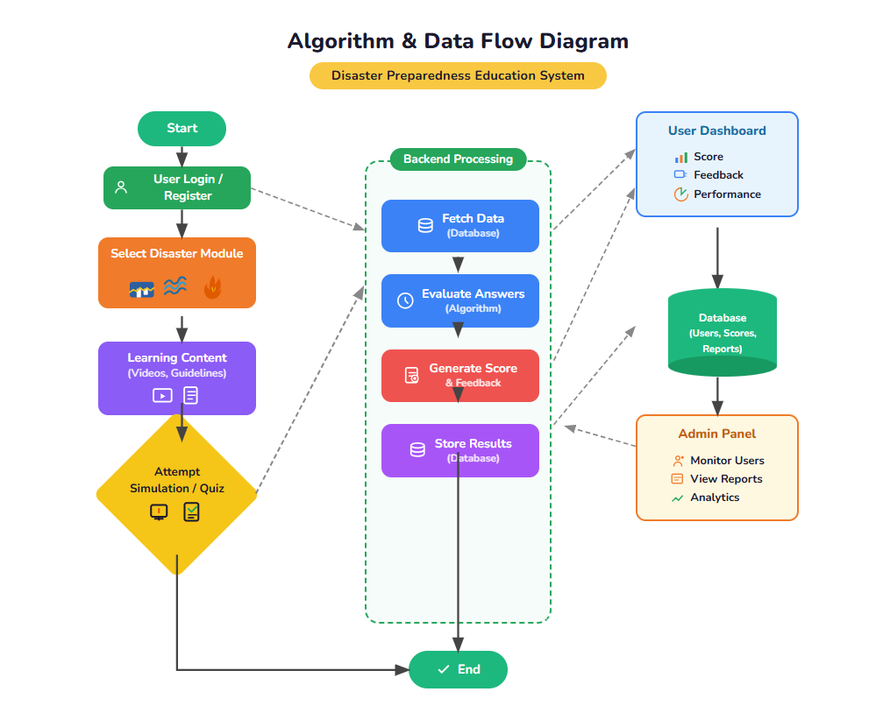

OUTCOMES AND FUTURE SCOPE.
A. Outcomes:
1. Student Dashboard
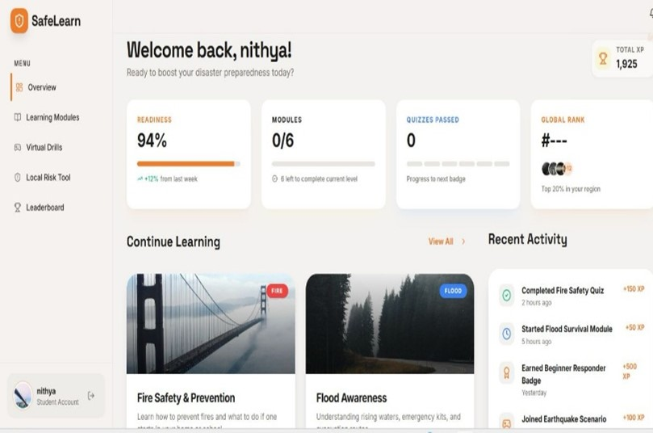
2. User Dashboard
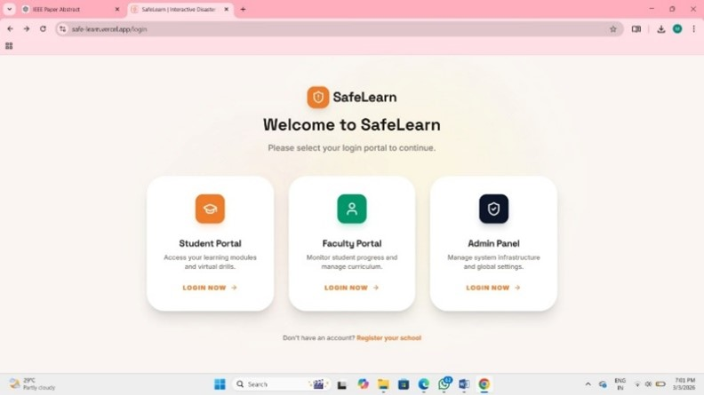
3. Faculty Dashboard
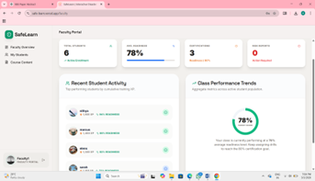
4. Admin Dashboard
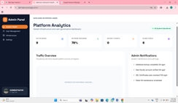
Putting the platform in front of actual users produced results across seven areas:
Classroom instruction tells students what they need to know.The learning modules changed that equation noticeably. Students who completed them retained far more — across disaster type identification, safety precautions, and emergency response procedures — than peers who had only received traditional classroom coverage. The difference was hard to ignore.
- Improved Decision-Making Skills — The simulation data told a clear story. First attempts were often hesitant and sometimes wrong. Repeated attempts were faster and more accurate. That progression — from uncertain to confident — is what the simulation component was built to produce, and it showed up consistently across users.
- Reduced Panic During Emergencies — Users who went through virtual drill sequences reported something worth paying attention to—less fear, more confidence, and a clearer mental model of what to do when something goes wrong. That shift in internal response is arguably more valuable than any knowledge score the system can generate.
- Better Institutional Preparedness Tracking — Administrators described the dashboard as the first time they had genuinely useful data on institutional preparedness. Not approximations. Not attendance records from an annual drill. Actual performance data, visible in real time, is actionable immediately.
- Structured and Continuous Learning — One drill a year produces one data point a year. The platform keeps that door open permanently.
- Performance Analysis — Persistent weaknesses in flood preparedness across a cohort. Strong quiz performance paired with poor simulation results.
- The difference between a preparedness program that lasts and one that quietly disappears after two years usually comes down to one thing — whether it ever became normal. Not celebrated, not mandated, just normal. The kind of thing students engage with because it is there and accessible, not because someone scheduled a reminder.
B. Future Scope
No platform is finished—it either grows or it stagnates. These seven directions represent the most meaningful ways this one could grow:
- AI Integration—Working through the same modules in the same order regardless of prior knowledge is not how effective learning actually works. Adaptive algorithms could change the equation—analyzing what each user has and has not mastered and redirecting them toward the content that will actually move the needle for them specifically. Training that adapts to the learner is fundamentally more useful than training that ignores who the learner is.
- Real-Time Alert Systems — The current platform teaches people what to do when disaster strikes. There is no reason it could not also tell them when disaster is approaching. Integrating live government warning feeds would add an operational dimension to what is currently a training tool—so the system that taught someone to respond to a cyclone is also the one that tells them one is three hours away.
- Mobile Application Development — The assumption that users always have reliable internet access is an assumption that fails in precisely the areas where disaster preparedness matters most. A dedicated mobile app with offline content and push notifications would break that dependency—ensuring that someone in a rural district with intermittent connectivity can still access safety modules, complete assessments, and receive alerts without needing a stable connection to do it.
- VR-Based Simulations—There is a ceiling to how much a screen-based simulation can replicate the experience of an actual emergency. Virtual reality raises that ceiling considerably. The spatial disorientation, the sensory pressure, and the need to look around and make decisions in three dimensions—none of that exists on a flat screen, and all of it exists in a well-designed VR environment. The cost is real, but so is the capability gap it would close.
- Multi-Institution Deployment — A platform used by one school is useful. A platform used by fifty schools across a region, all sharing infrastructure but each operating independently, is something closer to a preparedness network. Cloud-based scaling makes that possible without forcing institutions into a one-size-fits-all administrative model—each campus keeps its own data, its own reporting, and its own control over how the system is used locally.
- Community and Public Access — The students in a school are not the only people in a neighborhood. The communities surrounding educational institutions often face the same disaster risks with far less access to structured training.
- Multilingual Support—That decision sits badly in a country with twenty-two scheduled languages and hundreds of regional dialects. Adding multilingual support is not a nice-to-have feature—it is what the difference between a platform that is technically available to rural students and one that is genuinely usable by them actually looks like in practice.

REFERENCES
[1] D. P. Coppola,
“Introduction to international disaster management,”
[2] R. K. Lester and M. A. Krejci,
“Technology-enabled disaster preparedness education in schools,”
[3] J. M. Pine,
“Community resilience and disaster risk reduction strategies,”
[4] L. Bosher and A. Dainty,
“Disaster risk reduction and the built environment: A review of safety practices,”
[5] H. Rodriguez, E. L. Quarantelli, and R. R. Dynes,
“Handbook of disaster research,”
[6] K. Ronan and D. Johnston,
“Promoting community resilience in disasters: The role of schools and education,”
[7] T. Kapucu and L. Garayev,
“Collaborative decision-making in emergency management and disaster response,”
[8] M. Alexander,
“Principles of emergency planning and management,”
[9] S. E. Chang and T. Shinozuka,
“Measuring improvements in disaster resilience through training and preparedness programs,”
[10] R. Paton and D. M. Johnston,
“Disaster resilience: An integrated approach,”
[11] N. Dufty,
“Using social media and digital platforms for disaster education and communication,”
[12] S. S. Rao and M. K. Reddy,
“Web-based disaster management systems for educational institutions,”
[13] A. Tena-Chollet, L. D. Pérez, and J. R. Torres,
“Simulation-based learning models for emergency response training,”
[14] P. Mehta and S. Kulkarni,
“Cloud-based disaster monitoring and management systems,”
[15] G. Haddow and J. Bullock,
“Introduction to emergency management,”
[16] F. Norris, S. Stevens, B. Pfefferbaum, K. Wyche, and R. Pfefferbaum,
“Community resilience as a metaphor, theory, and strategy for disaster readiness,”
[17] A. K. Jain and V. Sharma,
“Integrating information technology into disaster preparedness education,”
[18] Y. Li and H. Zhai,
“Gamification approaches in disaster preparedness training programs,”
[19] M. Al-Shaer and H. Abdelgawad,
“Smart campus emergency response systems using IoT and real-time analytics.”

